**Formative Assignment __**

|  |  |
| --- | --- |
| Module Name | Application Integration |
| Course Name | Bachelor’s Degree in Software Engineering |
| Assignment Title | Build React JS Frontend Application |

|  |  |
| --- | --- |
| Learner Name | Francis Roel L. Abarca |

|  |
| --- |
| Learner declaration |
| I certify that the work submitted for this assignment is my own and research sources are fully acknowledged.  Student signature: Date: 5/20/23 |

**Trainer--- University training, SSG training,**

**Content development**

**Scope of this Assignment**

The main scope for this assignment is to develop a frontend website for ‘XYZ Cars Pte Ltd’ in React.

1. Install Node JS.

2. Create React application using “npx create-react-app [project name]” command.

3. Run application using “npm start” command.

4. Create Service to fetch the data from API.

5. Create methods to make HTTP REST call via Axios.

6. Create the required components to display the data coming from services.

7. Implement React Router to configure routing links.

**Task Wise Solutions**

1. Install Node.js
   1. Go to <https://nodejs.org/en/download> then select LTS and Windows Installer. 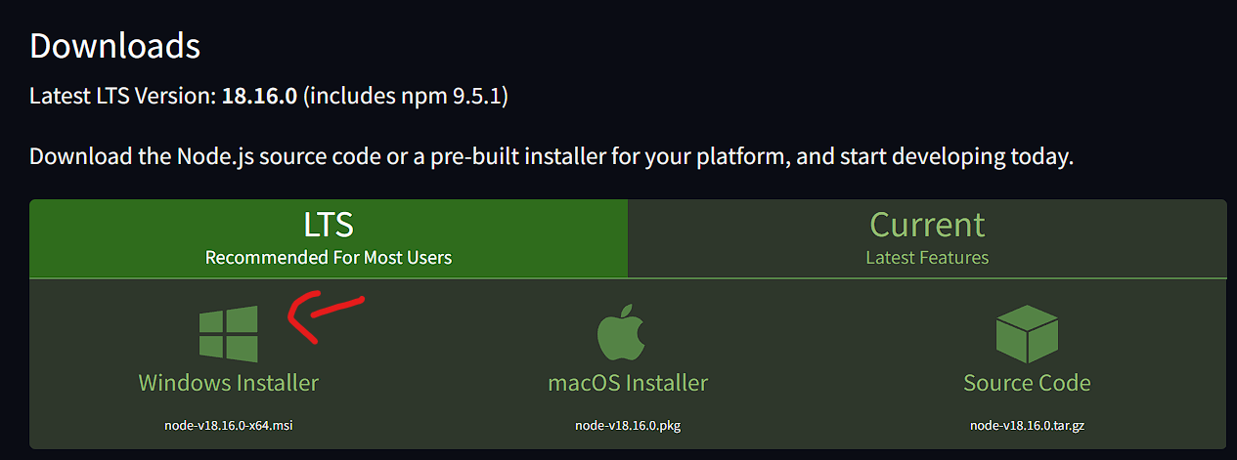
   2. Run the installation and follow the instructions given. 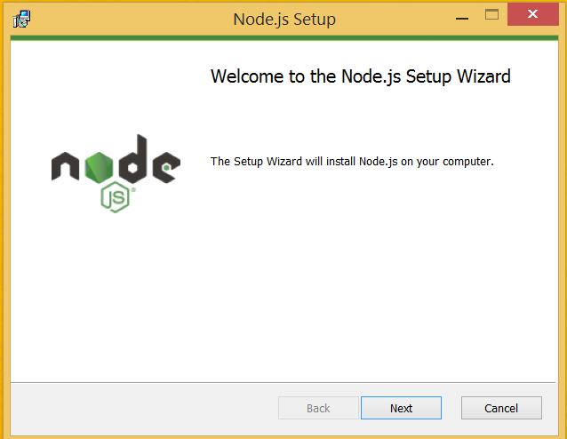 A screenshot of a computer

      Description automatically generated with medium confidence
   3. Once the installation is complete, it should be available in the Start Menu inside the Node.js folder.  
       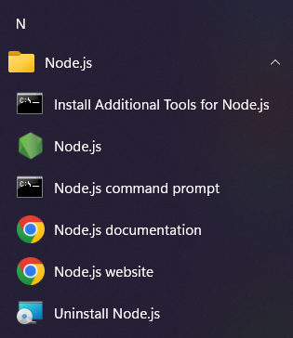
   4. You could also open Terminal and type “node -v” and “npm -v” to check the specific versions of Node.js and the Node Package Manager respectively. A screenshot of a computer

      Description automatically generated
2. Create React Application using “npx create-react-app [project name]” command.  
   A screenshot of a computer program

   Description automatically generated with medium confidence
3. Run application using “npm start” command.  
   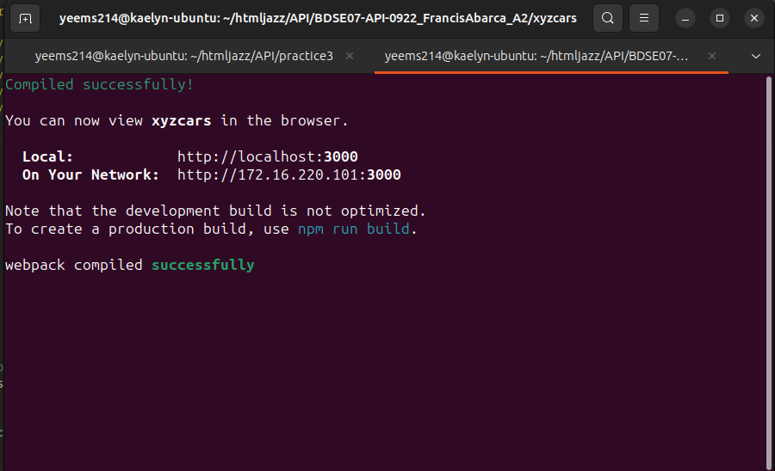
4. Create Service to fetch the data from API.
5. Sign In (GET)
   * User Log-in   
     A screenshot of a computer

     Description automatically generatedA screenshot of a computer

     Description automatically generated with medium confidence
   * MySQL ViewA screenshot of a computer

     Description automatically generated with medium confidence
6. Register (POST)
   * MySQL View (Before)  
     A screenshot of a computer

     Description automatically generated with medium confidence
   * Register  
     A screenshot of a computer

     Description automatically generated
   * Registration SuccessfulA screenshot of a computer

     Description automatically generated
   * Spring Boot CLI viewA screen shot of a computer

     Description automatically generated with low confidence
   * MySQL View (After) A screenshot of a computer

     Description automatically generated with medium confidence
7. Search User (GET)
   * Search “John” in Database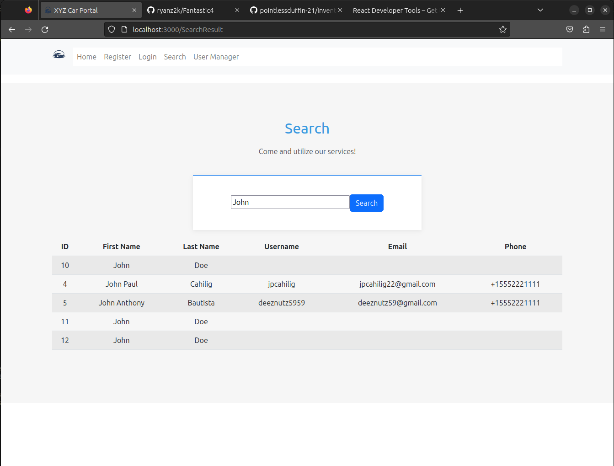
   * MySQL ViewA screenshot of a computer

     Description automatically generated with medium confidence

1. User Manager (GET)
   * User Manager ViewA screenshot of a computer

     Description automatically generated
   * MySQL ViewA screenshot of a computer

     Description automatically generated with medium confidence
2. Create methods to make HTTP REST call via Axios.
3. Install AxiosA screenshot of a computer screen

   Description automatically generated with low confidence
4. Import Axios to your .js projects that require it.  
   A screen shot of a computer code

   Description automatically generated with low confidence
5. Login.js A picture containing text, screenshot, font

   Description automatically generated
6. Register.js   
   A picture containing text, screenshot, font

   Description automatically generated
7. SearchResult.js  
   A computer code on a black background

   Description automatically generated with low confidence
8. UserManager.js   
   A screen shot of a computer code

   Description automatically generated with low confidence
9. Create the required components to display the data coming from services.
   1. Login.js  
      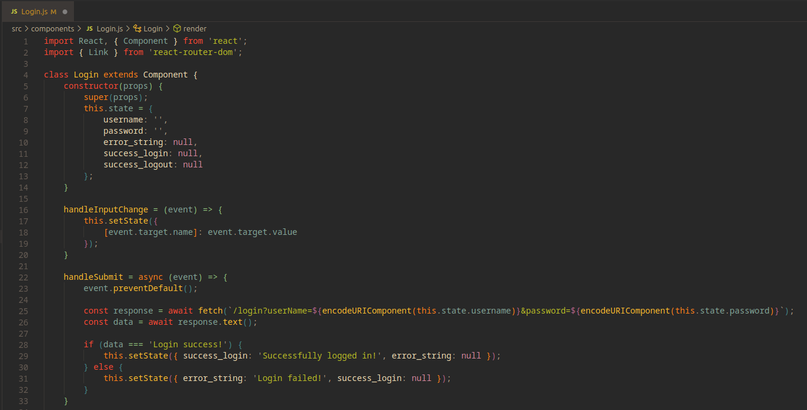  
      A screen shot of a computer program

      Description automatically generated with low confidence  
      A screen shot of a computer

      Description automatically generated with low confidence
   2. Register.js  
      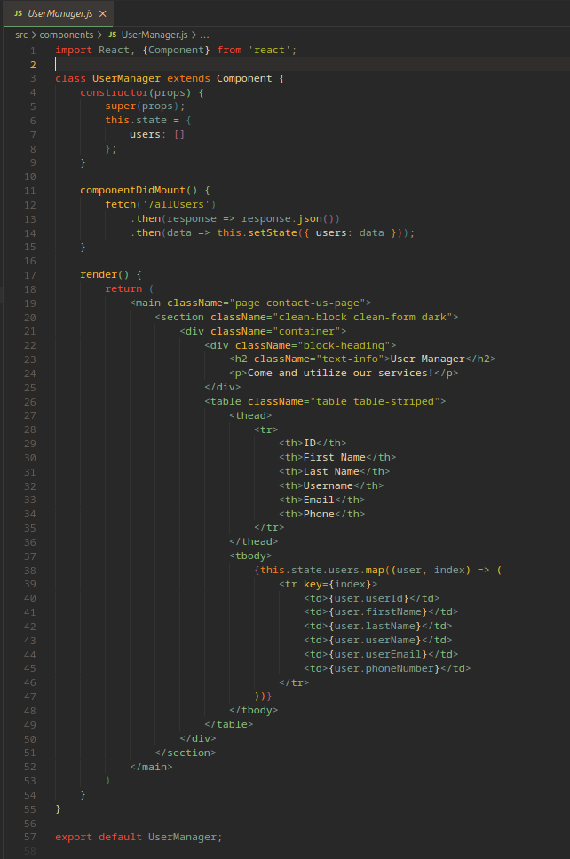
   3. SearchResult.js  
      A screen shot of a computer program

      Description automatically generated with low confidence A screen shot of a computer

      Description automatically generated with medium confidence
   4. UserManager.js 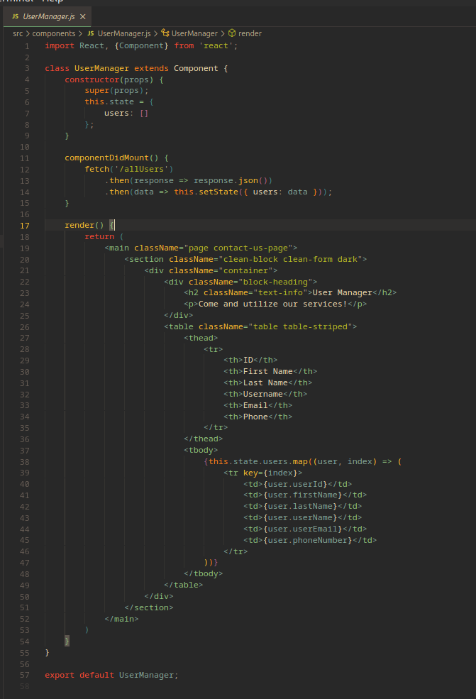

7. Implement React Router to configure routing links. 